TASK 1 code :
import java.util.Scanner; // Import the Scanner class
public class lab1task1 {
public static void main(String[] args) {
Scanner myObj = new Scanner(System.in); // Create a Scanner object
System.out.println("Equation 1:");
String expression1 = myObj.nextLine(); // Read user input
System.out.println("Expression 1 is: 3.0*x");
System.out.println("Equation 2:");
String expression2 = myObj.nextLine();
System.out.println("math expression 2: (3.0*x)+y");
System.out.println("Equation 3:");
String expression3 = myObj.nextLine();
System.out.println("math expression 3: (x + y) / 7.0");
System.out.println("Equation 4:");
String expression4 = myObj.nextLine();
System.out.println("math expression 4: (3.0 * x + y) / (z + 2.0)");
}
}

TASK 1 Output:
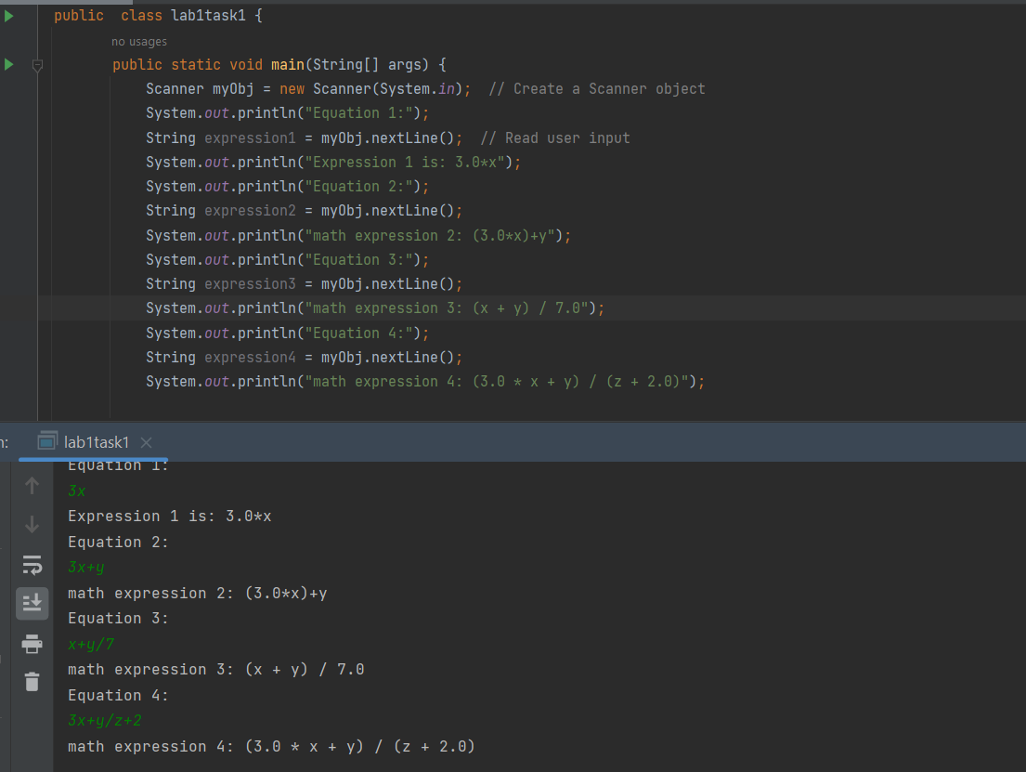
TASK2: (CODE)
import java.util.Scanner;
public class lab1task2 {
public static void main(String[] args) {
int marks1,marks2,marks3,marks4,marks5,sum;
float stuPerc;
Scanner myObj = new Scanner(System.in);
//System.out.println("For Student "+(i+1));
System.out.println("Enter Marks for 5 subjects:");
marks1 = myObj.nextInt();
marks2 = myObj.nextInt();
marks3 = myObj.nextInt();
marks4 = myObj.nextInt();
marks5 = myObj.nextInt();
sum = marks1+marks2+marks3+marks4+marks5;
stuPerc = (sum*100)/500;
System.out.println("Student's percentage is: " + stuPerc);
}
}

Task 2 Output:
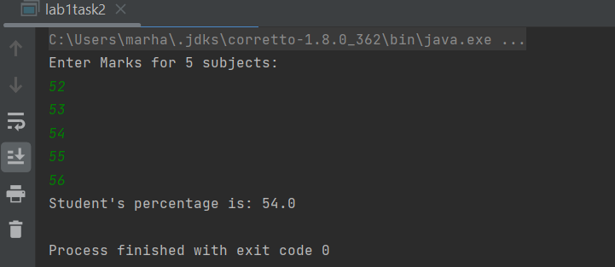

TASK 3A Code:
public class lab1task3 {
public static void main(String[] args) {
double num, den;
double finalFraction;
num = (9.5*4.5)-(2.5*3);
den = 45.5-3.5;
finalFraction = num/den;
System.out.println("The Output is: "+finalFraction);
}
}

TASK 3A Output:
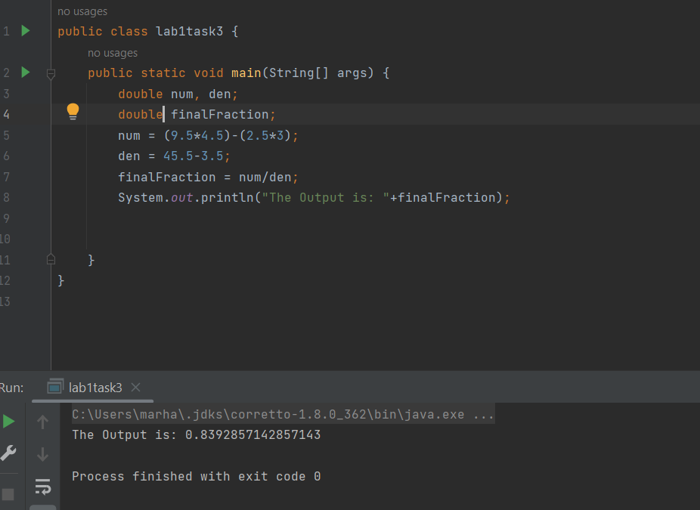
TASK 3B Code:
public class lab1task3b {
public static void main(String[] args) {
int sum;
sum = 1+2+3+4+5+6+7+8+9;
System.out.println("The Sum of These digit 0-9 is: "+sum);
}
}

TASK 3B Output:
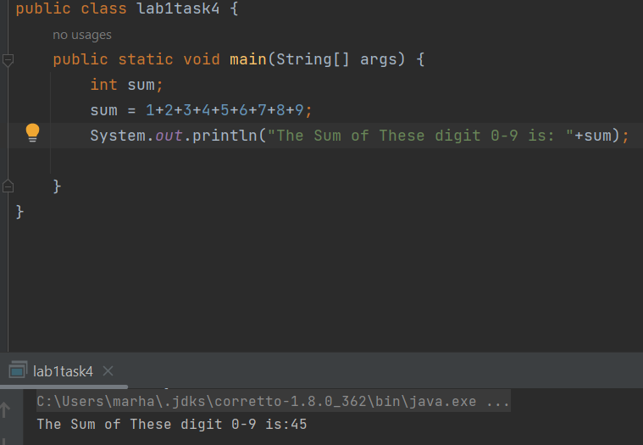
TASK 4 CODE:
import java.util.Scanner;
public class lab1task4 {
public static void main(String[] args) {
Scanner details = new Scanner(System.in);
System.out.println("Enter Your Name: ");
String name = details.nextLine();
System.out.println("Enter your id: ");
int rollNum = details.nextInt();
System.out.println("Enter Your Registered courses: ");
String course = details.next();
System.out.println("NAME "+"\tID"+"\tCourses");
System.out.println(name+"\t"+rollNum+"\t"+course);
}
}

TASK 4 Output:
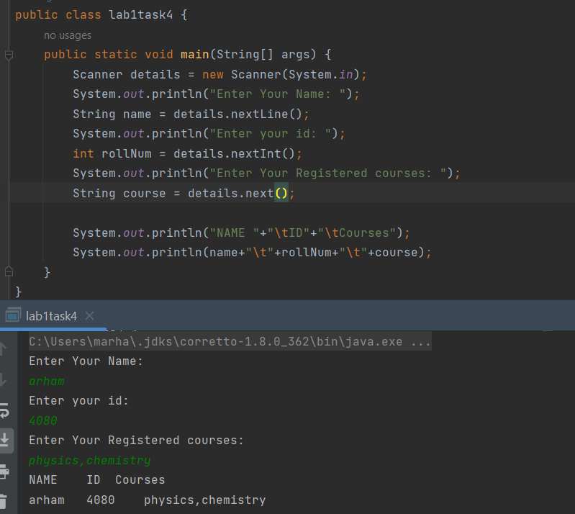

TASK 5 CODE:
public class lab1task5 {
public static void main(String[] args) {
double sum;
sum = 4.0 * (1 - (1.0/3) + (1.0/5) - (1.0/7) + (1.0/9) - (1.0/11));
System.out.println("Specified sum is: "+ sum);
}
}

TASK 5 OUTPUT:
